Laboratory practice No. 5: Graphs

Manuela Zapata Giraldo  Universidad Eafit  Medellín, Colombia  mzapatag1@eafit.edu.co | Luis Bernardo Zuluaga  Universidad Eafit  Medellín, Colombia  lbzuluagag@eafit.edu.co

3) Practice for final project defense presentation
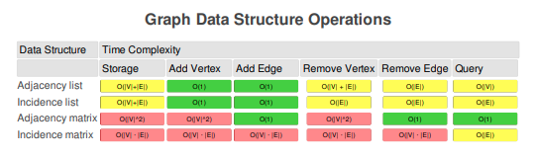

- We have a square matrix, of whatever size we want it to be (the size of the matrix is equivalent to the amount of nodes of our graph), and the values are inserted according to the relationship between vertices. Once the matrix is filled with the relationships between vertices, we must leave the remaining spaces empty so that we can save space in memory.
- When it comes to data nodes (graphs), implementation with a matrix tends to be more convenient due to how much easier the access to data is in matrices compared to linked lists. For example, the complexity of the search method with matrices is O(1) and with linked lists it’s O(n). However, when there is few data, implementation with linked lists is more convenient.
- Adjacency matrices, because it’s faster. The complexity with adjacency matrices is O(n^2log(n)) and with linked lists it’s O(n^2).
- Adjacency matrices, because Medellin’s map has a lot of data, which makes the implementation with matrices much more efficient than with linked lists.

4) Practice for midterms

 | 0 | 1 | 2 | 3 | 4 | 5 | 6 | 7
0 |  |  |  | 1 | 1
1 | 1 |  | 1 |  |  | 1
2 | 1 |  |  |  | 1 |  | 1
3 |  |  |  |  |  |  |  | 1
4 |  |  | 1
5
6 |  |  | 1
7

0 - > | [3,4]
1 - > | [0, 2, 5]
2 - > | [0, 4, 6]
3 -> | [7]
4 - > | [2]
5 - > | []
6 - > | [2]
7 - > | []

- B. O(n^2)

